Part 1
- The diagrams below show two types of wave produced on a slinky spring.
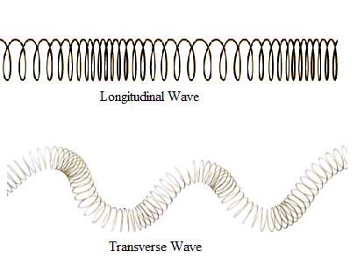
A
B

- Which one is a transverse wave? (1)

- What is the name of the other type of wave? (1)

- On both slinky diagrams, draw an arrow to show the direction of oscillation of the wave. (2)

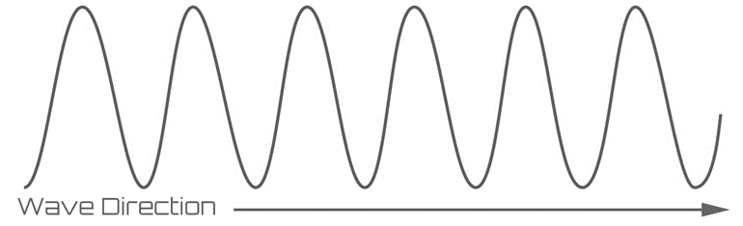
- On the diagram below, label the amplitude (a) and wavelength (λ) of the wave. (2)

- Radio waves from a distant galaxy are travelling at 3.0 x 10⁸m/s. If they have a wavelength of 28m, calculate the frequency of these waves. (3)

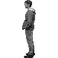
- The man sees the lightening and hears the thunder 4s later. The lightening hit the ground 1.3km away. Use this information to calculate the speed of sound in air. (2)
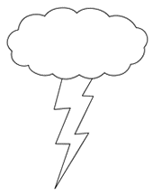

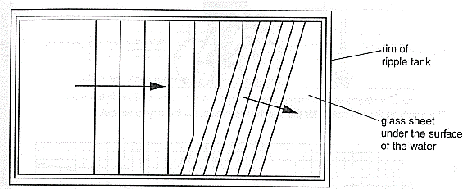
- The water waves produced in a ripple tank are shown below.
Bar producing the waves

- The bar producing the waves is vibrating at 2Hz and the waves are 0.03m apart. Calculate the speed of the water waves. (2)

- When the wave passes over the glass it refracts. State what will happen to each of the following properties of the wave when it refracts: (3)

Velocity

Wavelength

Frequency

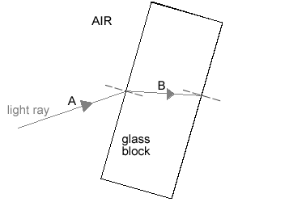
- The diagram shows a light ray shining on a block of glass.

- What is happening to the light ray at B? (1)

- Continue the ray of light as it leaves the glass block and label this as C. (1)

- Some of the light will be reflected before it enters the block. Draw this reflected ray and label
it D. (1)

- Not all the light that enters the block leaves the block. What has happened to this light that
does not leave the block? (1)

- (physics only) Sound waves in the air are converted into vibrations in solids within the ear (HT).
- Describe how the ear changes air vibrations into solid vibrations. (3)

- Explain why this process limits the frequency range humans can hear. (3)

- The diagram below shows ultrasound being used to produce an image of the inside the body.

muscle
fat
skin
Ultrasound emitter/receiver
screen
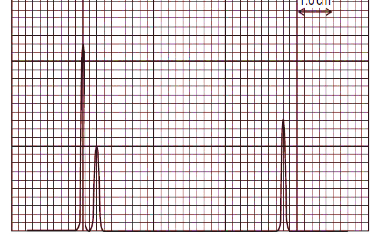

- Complete the following sentences. Choose from the correct words from the list below. (4)
media radiated transmitted reflected boundary
Ultrasound can travel through different materials – solids, liquids and gases. When
ultrasound meets a between two different
some of the ultrasound is and some is
. The reflected pulses are seen on the screen.
- Draw a trace on the screen to show how the ultrasound image will appear. (2)

- The diagram shows how Primary and Secondary seismic waves travel through the Earth.
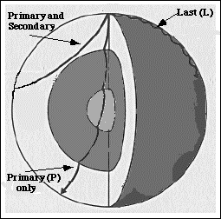

- What type of waves are S waves? (1)
- Why do the S waves not travel all the way through the Earth? (1)
- The P waves bend when they come to a new boundary surface. What is this bending
called? (1)
d. Explain why the P waves bend in this way. (3)
- Describe how echo sounding is used to locate a shoal of fish under a fishing trawler. (4)

